JAVA ASSIGNMENT-11 (21/11/2018)

1)Write a java program to find the Rate of Interest of Icici,Sbi,Andhra bank,Citybank using the concept of run time polymorphism

package raj;
class Bank
{
void bankData(){
System.out.println("Every bank has Interst");
}
}
class Icici extends Bank
{
void bankData()
{
System.out.println("The Rate Of Interest for ICICI bank is 18%");
}
}
class Sbi extends Bank
{
void bankData()
{
System.out.println("The Rate of Interest for SBI bank is 6.5%");
}
}
class AndhraBank extends Bank
{
void bankData()
{
System.out.println("The Rate Of Interest for Andhrabank is 7%");
}
}
class Citybank extends Bank
{
void bankData()
{
System.out.println("The Rate Of Interest for City bank is 8%");
}
}
public class BankInterest
{
public static void main(String[] args)
{
Bank obj;
obj=new Icici();
obj.bankData();
obj=new Sbi();
obj.bankData();
obj=new AndhraBank();
obj.bankData();
obj=new Citybank();
obj.bankData();
}
}

Output:
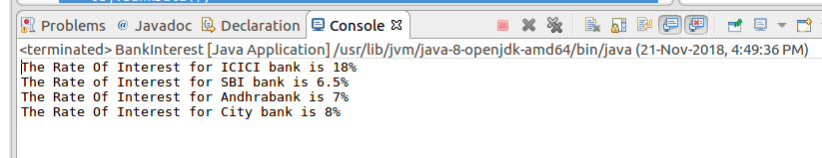

2)Write a java program to find the area of square,rectangle using method overloading.

package raj;
class Area
{
int a,b,area;
void area(int a)
{
area=a*a;
System.out.println("Area of Square is : "+area);
}
void area(int a,int b)
{
area=a*b;
System.out.println("Area Of Rectangle is: "+area);

}
}
public class AreaOverloading {

public static void main(String[] args) {
Area obj=new Area();
obj.area(2);
obj.area(2,89);
}

}

Output:
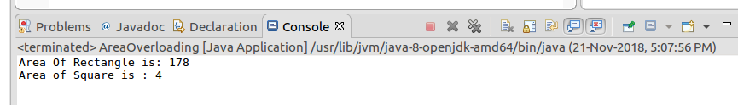

3)Write a java program to check overloading of main method.

package raj;

public class MainOverload {

public static void main(String[] args) {
System.out.println("Java is Object oriented language");
main(null,null);
}
public static void main(String args[],String arg[])
{
System.out.println("String is class in java");

}

}

Output:

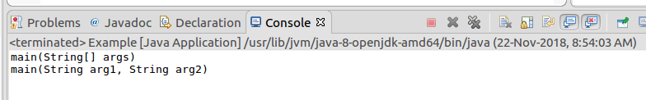

4)Write a java program to calculate the no of characters , no of white spaces, no of words of the following statement.

package raj;
public class CHSW {

public static void main(String[] args) {
String s="Java is object oriented programming language developed by James gosling";
String s1[]=s.split(" ");
String s2[]=s.split("");
int chcount=0;
int wcount=0;
for(int i=0;i<s1.length;i++)
{
wcount++;
}
for(int j=0;j<s2.length;j++)
{
chcount++;
}
System.out.println("No of words are :"+wcount);
System.out.println("No of characters are :"+chcount);
System.out.println("No of Spaces are: "+(wcount-1));
}

}

Output:
